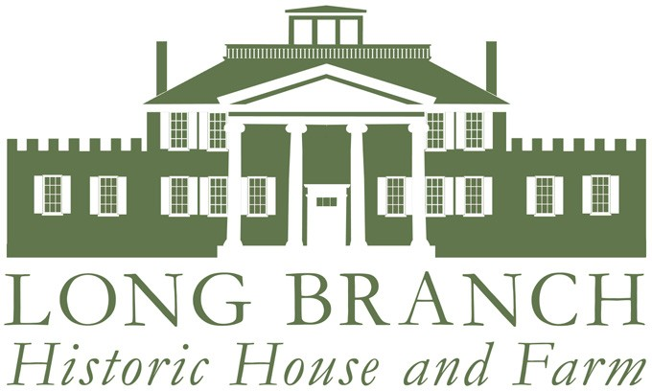

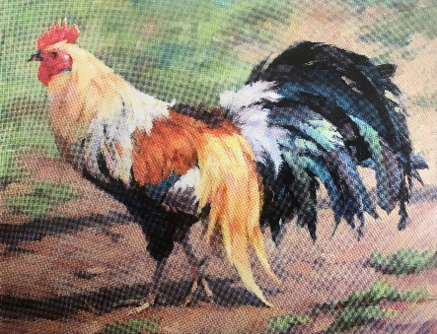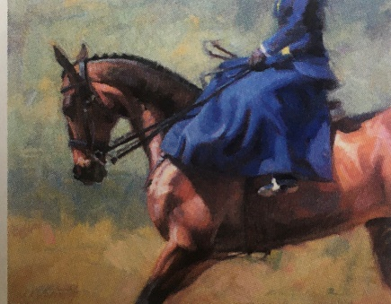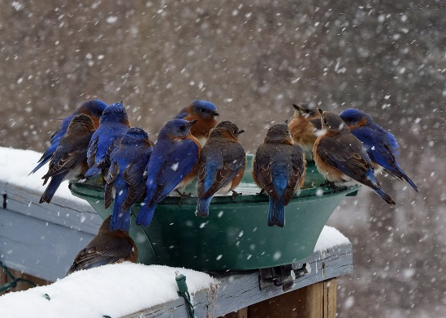

*President’sWelcome*

On behalf of the Board of Directors and staff, welcome to Long Branch Historic House & Farm.

We are pleased to announce that Long Branch is continuing to offer a complete schedule of events for the Fall/Winter Season – a contemporary photo exhibit in the East & West Gallery, Tuesday Night Bridge and a Holiday Open House . The full schedule of which is now available for you to view online, on our website calendar: [www.visitlongbranch.org/events/](http://www.visitlongbranch.org/events/)

Our historic house and grounds are available to rent for private celebrations, ceremonies and meetings as well - consider booking your holiday party now!

Feel free to stop by the house and property to explore on your own, independently during the week or with a guided tour hosted by Colette Poisson on Saturdays and Sundays from 12 -4pm.

We look forward to seeing you soon!

**Randy Buckley**

***THE GALLERIES AT LONG BRANCH PRESENT:***

***“Shared Visions”***

***Steven Parrish & Linda Volrath***

***September 5 – November 30, 2021***

* *Presidents Welcome*
* *The Galleries at Long Branch Present: Shared Visions & NTBeagles*
* *Event Schedule*
* *Horse Retirement Program*
* *Long Branch Weddings*

***INCLUDED IN THIS ISSUE***

***Hours of Operation:***

***Grounds: Sunrise to Sunset Daily***

*(Complimentary)*

***House: Monday to Friday******10am – 4pm***

***Saturday & Sunday 12 – 4pm***

*(By Donation)*

October - December 2021

*UPCOMING EVENTS SCHEDULE:*

*Long Branch Weddings*

Long Branch Weddings are set within an amazing 400-acre horse retirement farm nestled in the Shenandoah Valley of Virginia. Our historic property includes a circa 1811 Manor House, spectacular gardens and magnificent views of the Blue Ridge Mountains. We are located east of Winchester in Virginia’s renowned Horse Country, in close proximity to many award winning wineries and just one hour west of Washington Dulles International Airport.

Our main focus at Long Branch Weddings is the bride and groom and we have decorated and crafted special rooms in our mansion specifically for them in mind – including refreshments and last minute essentials. Additionally, a set of monogramed Long Branch glasses and a bottle of champagne are presented to each couple on the day of their wedding.

Please feel free to call us to discuss packages and best rates at 540-837–1856.

We look forward to showing you the beauty of Long Branch soon!

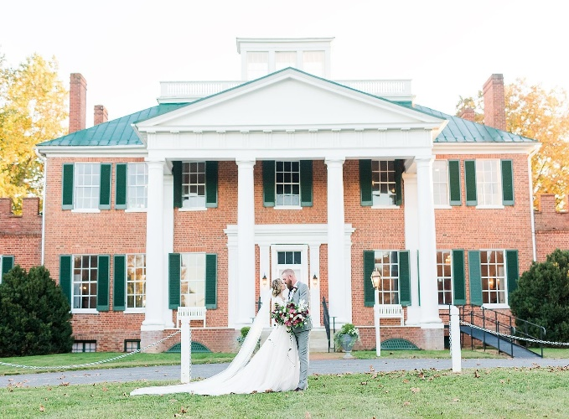

**Tuesday Night Bridge**

**Weekly**

5-7pm

$15/person including snacks, wine & beverages. RSVP by Noon Monday.

**September 5 – November 30: “Shared Visions. Paintings by Husband and Wife, Steven Parrish & Linda Volrath”**

Mon – Fri 10am – 4pm

Weekends 12 – 4pm

Free

**Nantucket Treweryn Beagles**

**Art Exhibit.**

**Coming Soon**

Mon – Fri 10am – 4pm

Weekends 12 – 4pm

Free

**Long Branch Holiday Open House**

**Coming Soon**

Saturday and Sundays in December

1-6pm

Free

***ON THE FARM….***

***The Long Branch Horse Retirement******Program*** *continues to be a source of pride at Long Branch Historic House and Farm, with currently 73 retired horses in residence on over 300 acres, close to the Shenandoah River and the Blue Ridge Mountains. Four-board fencing, automatic waterers and large run-in sheds are features of the program and our herds are segregated by gender on over two acres per horse. Our monthly package of* ***$225 per month*** *includes:*

* ***Regular hoof trims***
* ***Spring and Fall vaccinations***
* ***Yearly dental float***

***For more information or to complete an application, please visit us online***

***at*** [***www.visitlongbranch.org/horse-retirement/***](http://www.visitlongbranch.org/horse-retirement/)

***or call the office at 540-837-1856***

***Board of Directors:***

***President:*** *Randy Buckley*

***Vice President****: Lionel Chisholm*

***Secretary:*** *Doris Stimpson*

***Treasurer:*** *Cary Embury*

***Vice Treasurer:*** *Susi Bailey*

*Lisa Bell*

*Leslie Bowery*

*Marianne Casey*

*Matthew Klein*

*Robin Richards*

*Caroline Roberts, Emeritus*

*Ian Williams*

*Michael Williams*

***Staff:***

***Executive Director:*** *Matt Hannan*

***Farm Manager:*** *Joe Lewis*

***Deputy Farm Manager:*** *Billy Roberts*

***Administrative Assistant:*** *Karla Atkins*

**Long Branch Historic House and Farm**

**830 Long Branch Lane**

**P.O. Box 241**

**Millwood, VA 22646**

**540-837-1856**

[info@visitlongbranch.org](mailto:info@visitlongbranch.org)

[www.visitlongbranch.org](http://www.visitlongbranch.org)

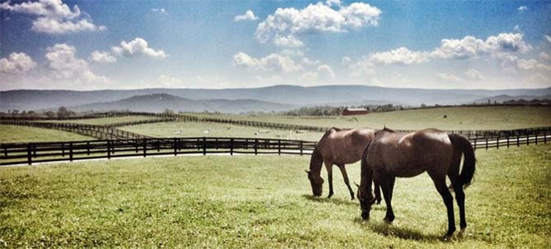

***The Long Branch House Committee proudly presents a new sideboard in***

***the Nelson Family Dining Room…***

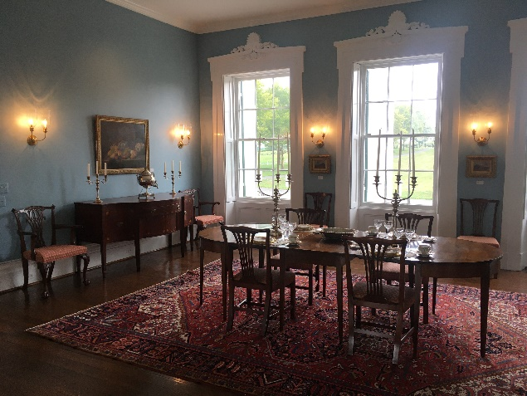

**COME WITNESS THE SPLENDOR OF THE**

**LONG BRANCH HOUSE & GROUNDS**

**YOURSELF!**

**Long Branch Historic House and Farm is a 501(c)3 non-profit organization**