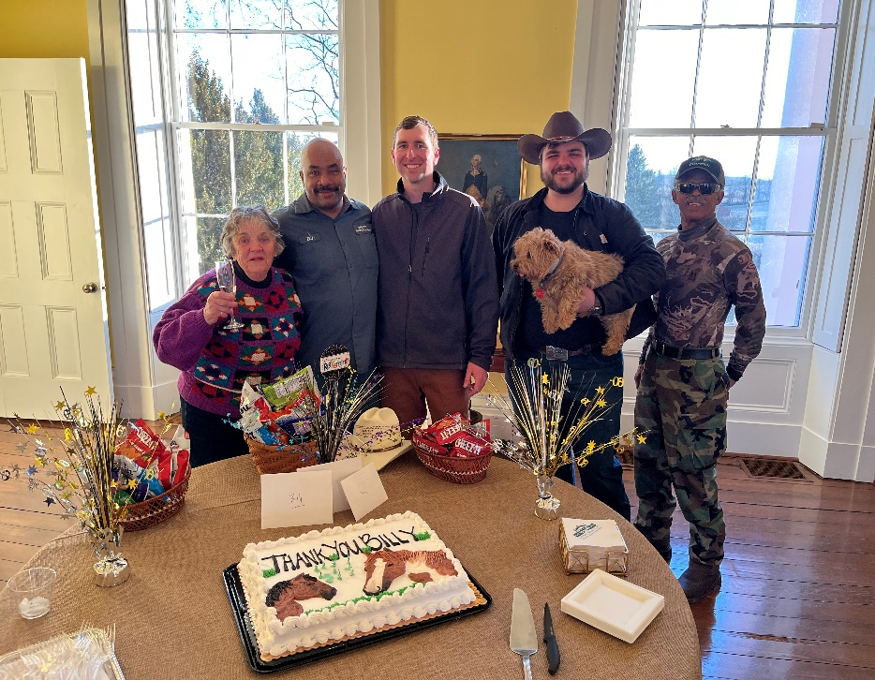

***LONG BRANCH MISSION***

***Our purpose is to preserve and utilize the assets of the Long Branch estate for the benefit of our local and regional communities. The historic house, active equine farm and scenic open space allow us to promote education, environmental preservation and host community events.***

*President’sWelcome*

On behalf of the Board of Directors and staff, welcome to Long Branch Historic House & Farm.

We are pleased to announce that Long Branch is continuing to offer a complete schedule of events through early Spring including the annual Speaker Series, Textiles of Asia and the Spring Landscape Show. The full schedule of which is now available on our website calendar under the ‘Happenings’ tab: [www.visitlongbranch.org/events/](http://www.visitlongbranch.org/events/)

Our historic house and grounds are available to rent for private celebrations, ceremonies and business meetings throughout the year.

Feel free to stop by the house and property to explore on your own, independently during the week or with a guided tour hosted by Colette Poisson on Saturdays and Sundays from 12 -4pm.

We look forward to seeing you soon!

**Randy Buckley**

***Long Branch Salutes***

***William Roberts***

*Thank you Billy for 13 super years looking after our horses, grounds and house. We wish you all the best*

*for a wonderful future!*

* *Presidents Welcome*
* *Speaker Series/Textiles of Asia/Spring Landscape Show*
* *Event Schedule*
* *Horse Retirement Program*
* *Long Branch Weddings*

***INCLUDED IN THIS ISSUE***

***Hours of Operation:***

***Grounds: Sunrise to Sunset Daily***

*(Complimentary)*

***House: Monday to Friday******10am – 4pm***

***Saturday & Sunday 12 – 4pm***

*(By Donation)*

February – May, 2022

*UPCOMING EVENTS SCHEDULE:*

*Long Branch Weddings*

Long Branch Weddings are set within an amazing 400-acre horse retirement farm nestled in the Shenandoah Valley of Virginia. Our historic property includes a circa 1811 Manor House, spectacular gardens and magnificent views of the Blue Ridge Mountains. We are located east of Winchester in Virginia’s renowned Horse Country, in close proximity to many award winning wineries and just one hour west of Washington Dulles International Airport.

Our main focus at Long Branch Weddings is the bride and groom and we have decorated and crafted special rooms in our mansion specifically for them in mind – including refreshments and last minute essentials. Additionally, a set of monogramed Long Branch glasses and a bottle of champagne are presented to each couple on the day of their wedding.

Please feel free to call us to discuss packages and best rates at 540-837–1856.

We look forward to showing you the beauty of Long Branch soon!

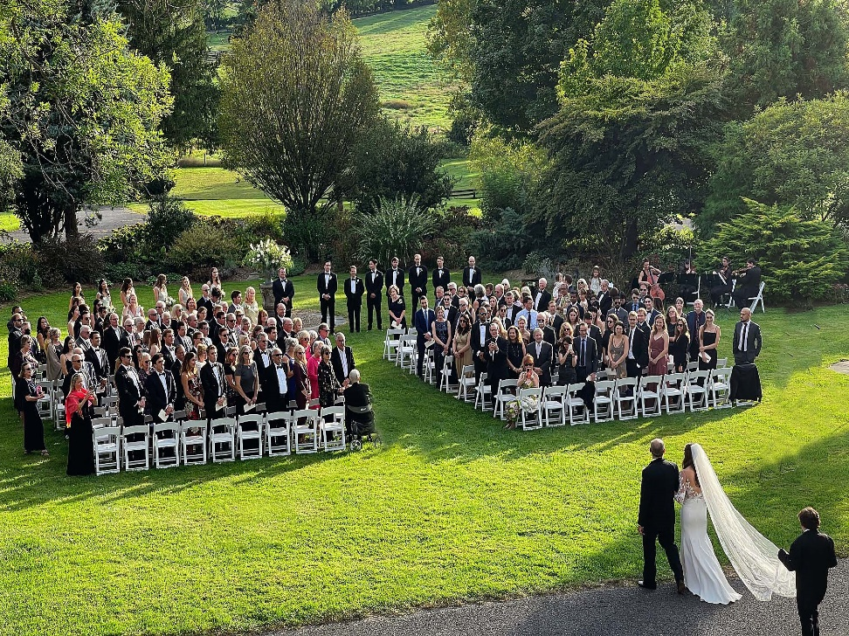

**SPEAKER SERIES**

**Sundays @ 6pm**

**$25/person**

**February 6: “Becoming a Published Author”** by Jason Queen

**February 27: “Bemer Therapy”** by Dr. Rebecca Verna

**March 13: “Blind Bombing, How Microwave Radar Brought the Allies to D-Day and Victory in WWII”** by Norman Fine

**March 20: “Fox World”** by Jack Russell

**March 27: “What Happened to the American Health Care System: A Physician Perspective”** by Dr. Laura Dabinett

**THE GALLERIES AT**

**LONG BRANCH**

**Mon- Fri 10-4**

**Sat/Sun 12-4**

**Free**

**March 7-31: “Textiles of Asia”**

**April 9 – May 8: “Spring Landscape Show”** featuring Winslow McCagg/Meg Caldwell/Anna Billman/Leigh Henry

**April 16: “Spring Landscape Show”** Opening Reception 5-8pm

**May 8: “Spring Landscape Show”** Closing Reception 5-8pm

***ON THE FARM….***

***The Long Branch Horse Retirement******Program*** *continues to be a source of pride at Long Branch Historic House and Farm, with currently 73 retired horses in residence on over 300 acres, close to the Shenandoah River and the Blue Ridge Mountains. Four-board fencing, automatic waterers and large run-in sheds are features of the program and our herds are segregated by gender with over two acres per horse. Our monthly package of* ***$250 per month*** *includes:*

* ***Regular hoof trims***
* ***Spring and Fall vaccinations***
* ***Yearly dental float***

***For more information or to complete an application, please visit us online***

***at*** [***www.visitlongbranch.org/horse-retirement/***](http://www.visitlongbranch.org/horse-retirement/)

***or call the office at 540-837-1856***

***Board of Directors:***

***President:*** *Randy Buckley*

***Vice President****: Lionel Chisholm*

***Secretary:*** *Doris Stimpson*

***Treasurer:*** *Cary Embury*

***Vice Treasurer:*** *Susi Bailey*

*Lisa Bell*

*Leslie Bowery*

*Marianne Casey*

*Matthew Klein*

*Robin Richards*

*Caroline Roberts, Emeritus*

*Ian Williams*

*Michael Williams*

***Staff:***

***Executive Director:*** *Matt Hannan*

***Administrative Assistant:*** *Karla Atkins*

***Farm Manager:*** *Joe Lewis*

***Deputy Farm Manager:*** *Jordan Silva*

**Long Branch Historic House and Farm**

**830 Long Branch Lane**

**P.O. Box 241**

**Millwood, VA 22646**

**540-837-1856**

[info@visitlongbranch.org](mailto:info@visitlongbranch.org)

[www.visitlongbranch.org](http://www.visitlongbranch.org)

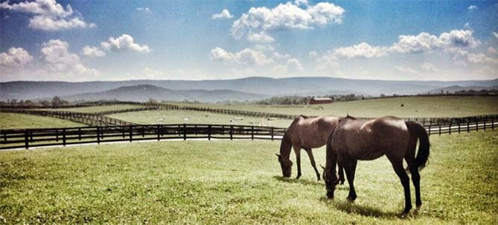

***The Sheila MaQueen Gardens present:***

***Winter blooming Witchhazel***

***(Hamemelis virginiana)***

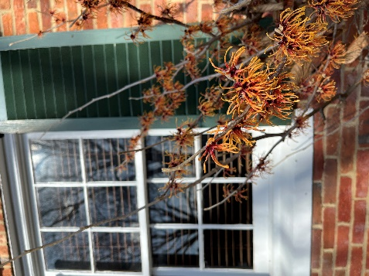

**Come witness the splendor of the Long Branch**

**house and gardens yourself!**

**Long Branch Historic House and Farm is a 501(c)3 non-profit organization**