*President’s Welcome*

On behalf of the Board of Directors and staff, welcome to Long Branch Historic House & Farm.

In 1990, Mr. Harry Z. Isaacs, the last private owner of Long Branch, created a foundation leaving the estate for the enjoyment of the public.

We are pleased to offer the following spring schedule which is now available on our website calendar under the ‘Happenings’ tab: [www.visitlongbranch.org/events/](http://www.visitlongbranch.org/events/)

Feel free to explore the house and gardens on your own during the week, or during a privately guided tour hosted by Colette Poisson on Saturdays and Sundays from 12 -4pm.

We look forward to seeing you soon,

**Randy Buckley**

*Long Branch Historic House and Farm,* in partnership with *Oak Spring Garden Foundation,*

Proudly Presents:

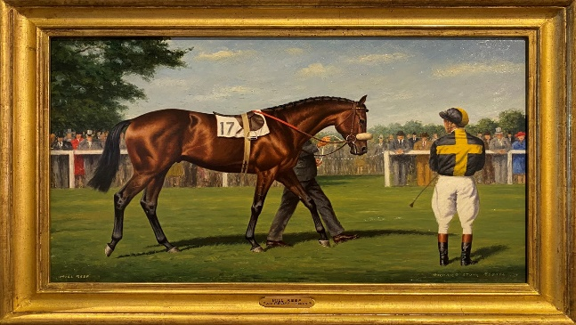

*“****Mill Reef: A Legacy of Heart****”*

A documentary film by Cassidy Glascock,

With accompanying exhibit.

Saturday April 29 @ 11am/12pm/2pm

Sunday, April 30 @ 12pm/2pm

$10/person

Reservations required

Please call 540-837-1856 for more information



***Hours of Operation:***

***Grounds: Sunrise to Sunset Daily***

*(Free)*

***House: Monday to Friday******10am – 4pm***

*(Self-guided tours by donation)*

***Saturday & Sunday 12 – 4pm***

*($10 per person including a guided tour)*

***LONG BRANCH MISSION***

***Our purpose is to preserve and utilize the assets of the Long Branch estate for the benefit of our local and regional communities. The historic house, active equine farm and scenic open space allow us to promote education, environmental preservation and host community events.***

April - August, 2023

The Galleries at Long Branch

Present:

*“****The Spring Art Show****”*

Featuring paintings by

Peggy Duvall and Zoe Hawkins

March 18 – May 28

Art Show Reception Friday, April 14

6-8pm

Free

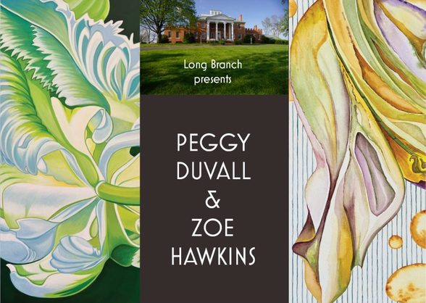



*EVENT*

*SCHEDULE*

***Spring Art Show***

March 18 – May 28

M-F 10am-4pm/Sat & Sun 12-4pm

Free

***Easter Egg Hunt***

Saturday, April 8

12-3pm

$10 per car

***Spring Art Show Reception***

Friday, April 14

6-8pm

Free

***Clarke County Garden Week***

Saturday April 22

12-4pm Open House

Free

***“Mill Reef: A Legacy of Heart” Exhibit & Film***

Saturday, April 29 @ 11am/2pm/4pm

Sunday, April 30 @ 12pm/2pm

$10 person

Reservations required

***Clarke Conservation Fund***

Encouring Biodiversity in Clarke!

Wednesday May 10 @ 5:30-7:30pm

Free

***Summer Art Show – Bernie Lewis Photo Exhibit***

June 9 – August 27

M-F 10am-4pm/Sat & Sun 12-4pm

Free

***Summer Art Show Reception***

Friday June 16

6-8pm

Free

***Summer Celebration***

Saturday July 22

6-9pm

$85/person

***ON THE FARM….***

The Annual Easter Egg Hunt

**Saturday, April 8**

**12 - 3pm**

**$10/**vehicle - **Cash accepted at the entrance gate.**

**Hunt times:**

**2:15** children up to 5 years old

**2:30** children 6 - 10 years old

**2:45** children 11 - 15 years old

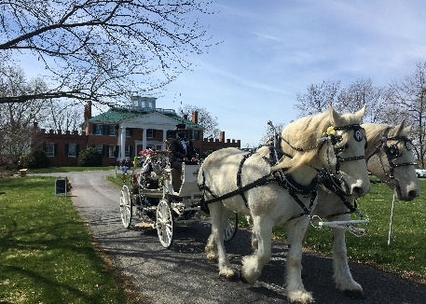

Long Branch Horse Retirement

The Long Branch Horse Retirement Program continues to be a source of pride at Long Branch, with currently 74 retired horses in residence on 400 acres, close to the Shenandoah River and the Blue Ridge Mountains.

Four-board fencing, automatic waterers and large run-in sheds are features of the program and our herds are segregated by gender with over two acres per horse.

Our monthly package of $250 per month includes:

* Regular hoof trims
* Spring and Fall vaccinations
* Yearly dental float
* Hay as needed

For more information or to complete an application, please visit us online at:

[www.visitlongbranch.org/horse-retirement/](http://www.visitlongbranch.org/horse-retirement/)

***Board of Directors:***

***President:*** *Randy Buckley*

***Vice President****: Lionel Chisholm*

***Secretary:*** *Doris Stimpson*

***Treasurer:*** *Cary Embury*

***Vice Treasurer:*** *Marianne Casey*

*Lisa Bell*

*Lori Dabinett*

*Andrew Ferrari*

*Frances Greene*

*Philip Hughes*

*Matthew Klein*

*Robin Richards*

*Caroline Roberts, Emeritus*

*Ian Williams*

*Michael Williams*

***Staff:***

***Interim Ex Director:*** *Marianne Casey*

***Administrative Assistant:*** *Christine Reed*

***Farm Manager:*** *Joe Lewis*

***Assistant Farm Manager:*** *Jordan Silva*

**Long Branch Historic House and Farm**

**830 Long Branch Lane**

**Boyce, VA 22620**

**Mailing Address:**

**P.O. Box 241**

**Millwood, VA 22646**

**540-837-1856**

[www.visitlongbranch.org](http://www.visitlongbranch.org)

**Long Branch Historic House and Farm is a 501©3 non-profit organization**

**First-Cut Long Branch Round Bales For Sale:**

**$30**

**Please Contact Farm Manager:**

**Joe Lewis**

**540-327-1196**